**[Overview**

This report provides insights derived from the analysis of the used car market in India from 1998 to 2020. It highlights key trends, customer preferences, and actionable recommendations to drive strategic decision-making.

**Key Insights**

1. **Sales Trend**:
   * Used car prices showed significant growth between 2005 and 2016, peaking in 2016 before declining thereafter.
   * This decline may indicate market saturation, economic conditions, or shifting consumer preferences.

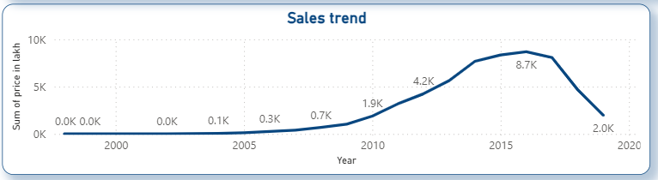

**Further Investigation**:

* Analyze economic or regulatory events post-2016 that might have influenced the used car market.
* Study customer purchase behavior to identify reasons for the decline in demand.

1. **Car Transmission**:
   * Manual transmission vehicles dominate the market, accounting for 72.27% of sales.
   * Automatic cars represent 27.73%, showing slower adoption, though urban areas might reflect a growing trend.

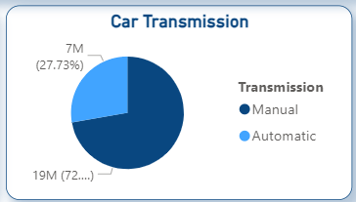

**Further Investigation**:

* Conduct a city-wise analysis to determine where automatic transmission demand is higher.
* Study if younger or first-time car buyers prefer automatic cars to predict future shifts in demand.

1. **Fuel Type Preferences**:
   * Diesel cars lead the market with 52.68%, followed by Petrol vehicles at 46.34%.
   * Alternative fuel options (CNG, LPG, Electric) have minimal market penetration, reflecting untapped potential.

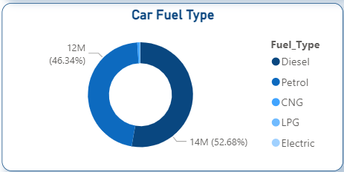

**Further Investigation**:

* Evaluate government policies promoting electric vehicles (subsidies, tax breaks) and their potential market impact.
* Study fuel price trends and their correlation with the shift in consumer preferences.

1. **Kilometers Driven by Car Model**:
   * Models like BMW X5 (6.6M km) and Maruti Swift Dzire VDI (4.5M km) show high reliability and customer trust.
   * Demand spans both luxury (BMW) and economical vehicles (Maruti Swift), indicating diverse customer needs.

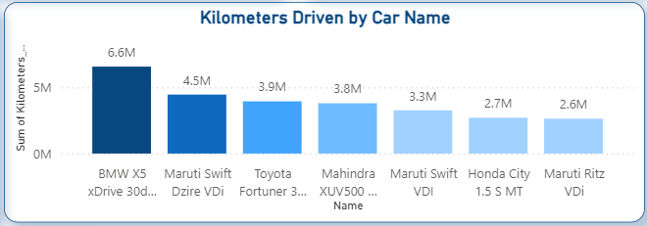

**Further Investigation**:

* Investigate why certain models have higher mileage usage. Is it due to superior build quality, customer trust, or specific use cases (e.g., taxis)?
* Analyze customer feedback on these models to improve offerings or highlight their strengths in marketing.

1. **Geographical Analysis**:
   * High sales concentrations in cities such as Combitore, Mumbai, Kochi, Hyderabad, Bangalore, and Delhi reflect regional economic strength and purchasing power.
   * These cities represent key growth opportunities.

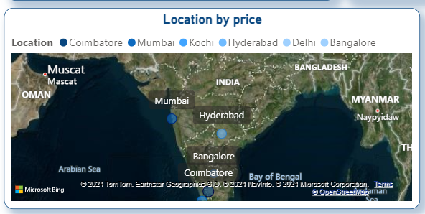

**Further Investigation**:

* Conduct a deep dive into demographic and economic factors in these cities to identify why they perform better.
* Explore underperforming regions and analyze barriers to entry (e.g., lack of dealerships, lower income levels).

1. **Ownership Type**:
   * First-owner cars dominate the market (22M sales), reflecting consumer preference for less-used vehicles.
   * Second-owner vehicles account for only 4M sales, suggesting potential for improvement in trust and affordability.

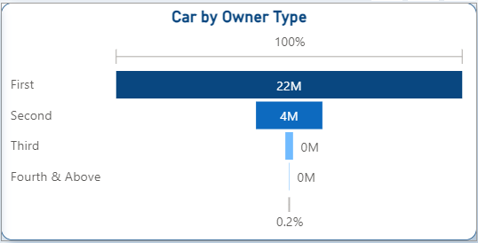

**Further Investigation**:

* Study customer perception of second-owner cars and barriers to purchase.
* Assess resale values of first-owner cars across brands/models to improve pricing strategies.

1. **Market Metrics**:
   * Total cars sold: 26M
   * Total kilometers driven: 426M

**Recommendations for Strategic Decision-Making**

1. **Sales Growth Revival**:
   * Investigate the sales decline post-2016 to identify root causes, such as economic conditions or regulatory changes.
   * Revamp marketing strategies with discounts, trade-in programs, and financing options to boost demand.
2. **Focus on Fuel Types**:
   * Maintain a strong inventory of petrol and diesel vehicles to meet current demand.
   * Invest in promoting and educating customers about alternative fuels (electric, CNG) to align with future market shifts.
3. **Leverage Manual Transmission Dominance**:
   * Focus inventory and marketing efforts on manual cars to cater to the majority.
   * Gradually increase the availability of automatic cars, particularly in urban areas.
4. **Geographic Expansion**:
   * Strengthen presence in cities like Mumbai, Bangalore, and Hyderabad by increasing dealership networks and localized marketing efforts.
   * Explore underserved regions to identify and address barriers to sales.
5. **Owner Type Preference**:
   * Emphasize first-owner car sales by highlighting their reliability and condition in marketing campaigns.
   * Enhance certification and inspection programs to build trust in second-owner vehicles.
6. **Prepare for Market Evolution**:
   * Gradually introduce eco-friendly vehicles, collaborating with manufacturers to address the growing interest in electric and hybrid options.
   * Monitor government policies for potential incentives and subsidies that could drive demand for alternative fuel vehicles.
7. **Model-Specific Marketing**:
   * Promote popular, high-mileage models like BMW X5 and Maruti Swift Dzire VDI, emphasizing their reliability and performance.

**Conclusion**

This analysis highlights key trends and opportunities in the D.A Autos Indian used car market. By addressing consumer preferences, leveraging regional insights, and preparing for emerging trends, stakeholders can optimize operations and ensure sustainable growth. Immediate actions should focus on reviving sales post-2016, strengthening manual car and fuel-specific strategies, and preparing for a gradual transition to eco-friendly vehicles.